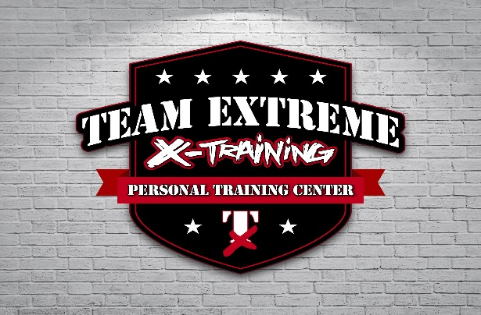

TEAM EXTREME X-TRAINING NJ

MOBILE PERSONAL TRAINING CENTER
PERSONAL TRAINING –IN-HOME EXERCISE CLASSES
- CERTIFIED PERSONAL TRAINERS, CPR/AED
- 1 ON 1
- ALL ARE WELCOME – OPEN TO ALL
- YOUR HOME, GYM OR A LOCAL PARK
- VIRTUAL CLASSES ALSO AVAILABLE – LIVE & INTERACTIVE
- WE BRING OUR OWN EQUIPMENT

HOURS: BY APPOINTMENT ONLY
90-Minute class - $190
1-Hour class - $125
45-minutes - $90
30-minute class - $60

Forms of payment: we work with Self-Direction budgets Acumen, Easter Seals, Venmo, Zelle

4 Matthews St., Williamstown, NJ 08094
CALL 347-533-2252

